A000-Afr-Tchad-Sao-Bronze Armlet-Mid 20th c

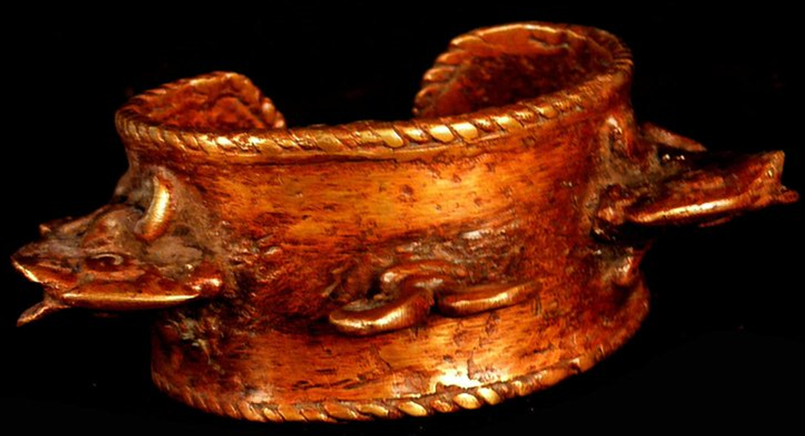 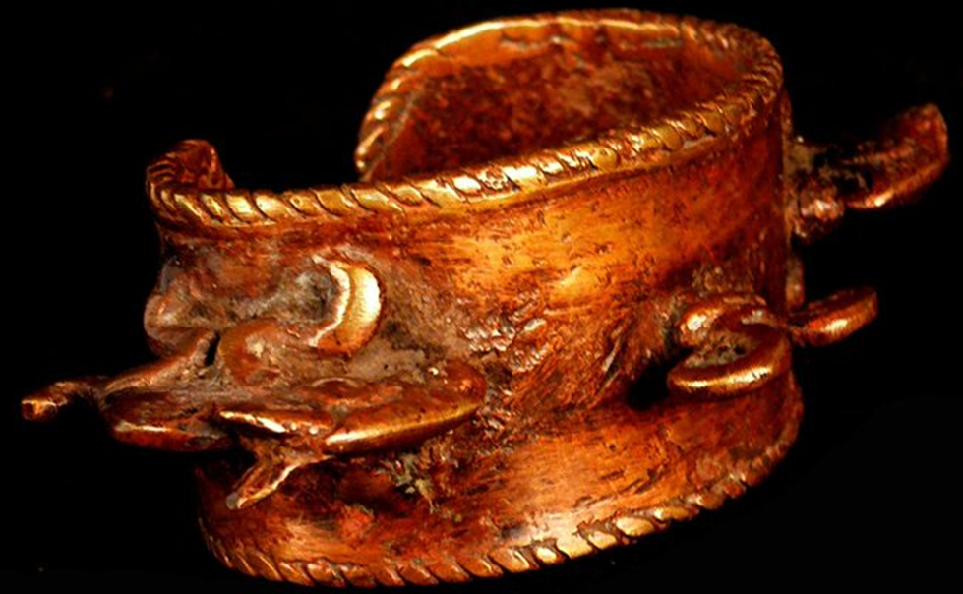

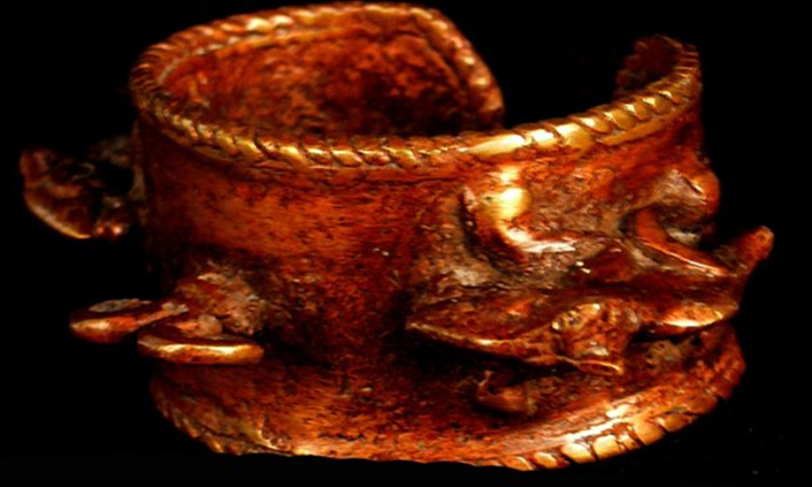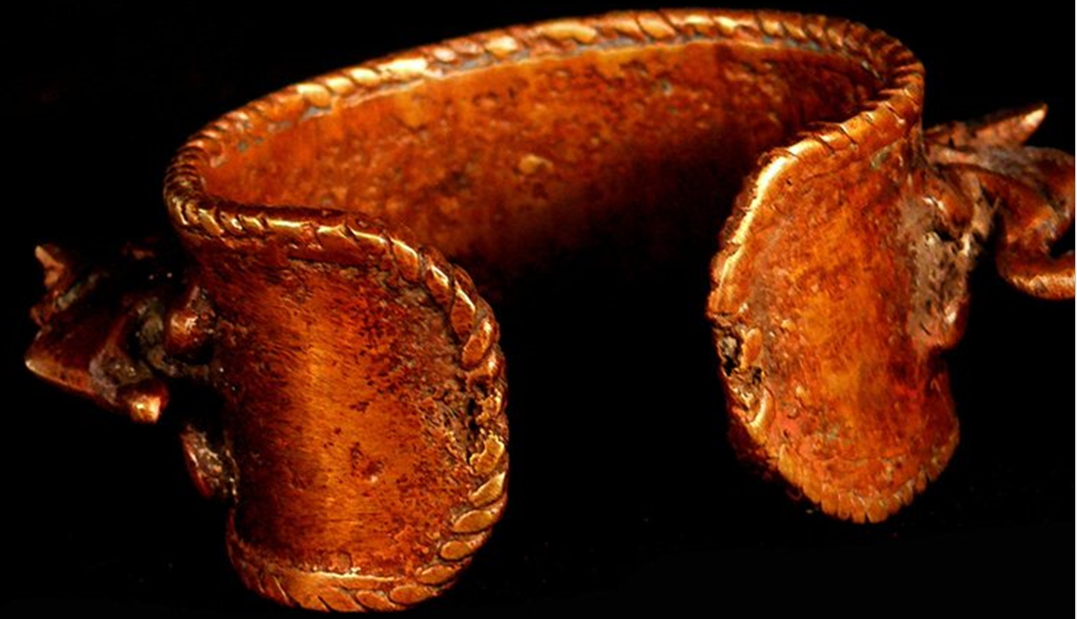

Case No.: 6

**Accession No.**

**Formal Label:**

**Display Description:**

Beautiful large bracelet with riders on horseback in bronze with a beautiful warm patina. This band was made in Chad with the 'cire perdue' technique, so unique in its kind. It is very refined and beautiful in detail. There are 3 horsemen in this band, two with shield and bow and arrow, the third with a trumpet.

Horses and horsemen are highly regarded in Chad, and symbolize wealth and power.

This bracelet was used as a means of payment in the past days, or was part of a dowry.

**LC Classification:**

**Date or Time Horizon: mid 20th c**

**Geographical Area:**

**Map:**

**GPS coordinates:**

**Cultural Affiliation:**

**Medium: bronze**

**Dimensions: W 3 in**

**Weight:** 0.526 pounds

**Condition:**

**Provenance:**

**Discussion:**

**References:**